Nature Art

Seamus Heaney loved the landscape around him and used it as a source of inspiration for many pieces of his work.
Your task is to go for a walk within your landscape (even if it’s just your garden) and collect objects from nature like leaves, twigs and flowers etc to create a piece of Nature Art. You could start with your name…samples attached. Enjoy….and remember to wash your hands!

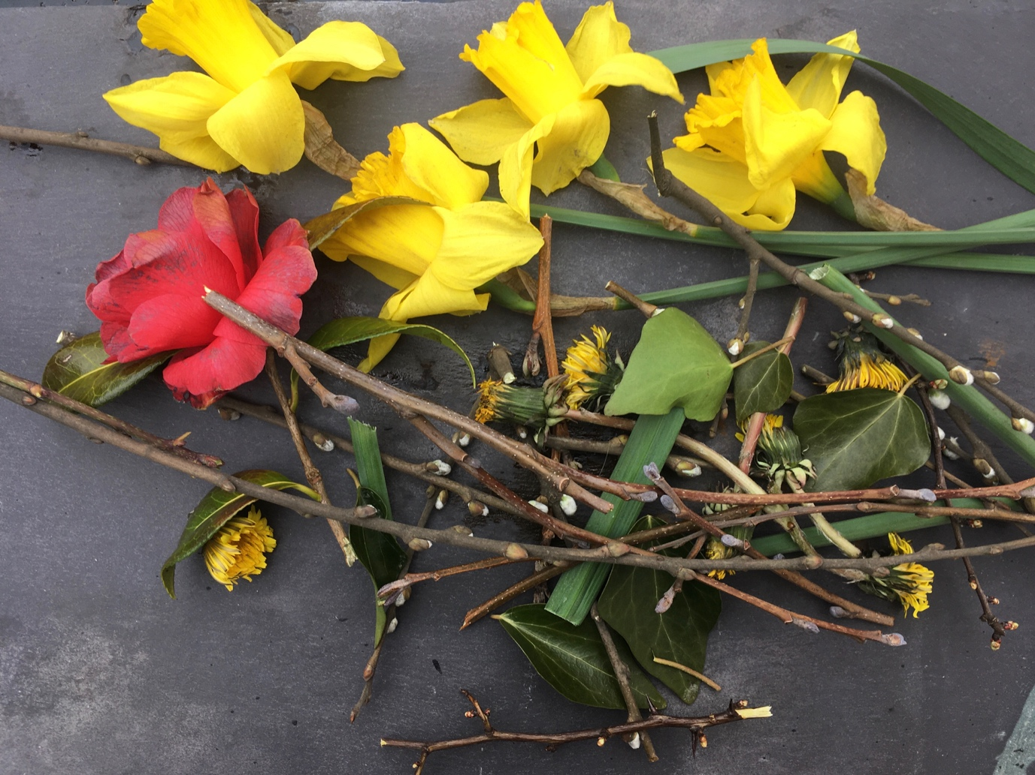

Gather a selection of found objects from nature and lay them out.

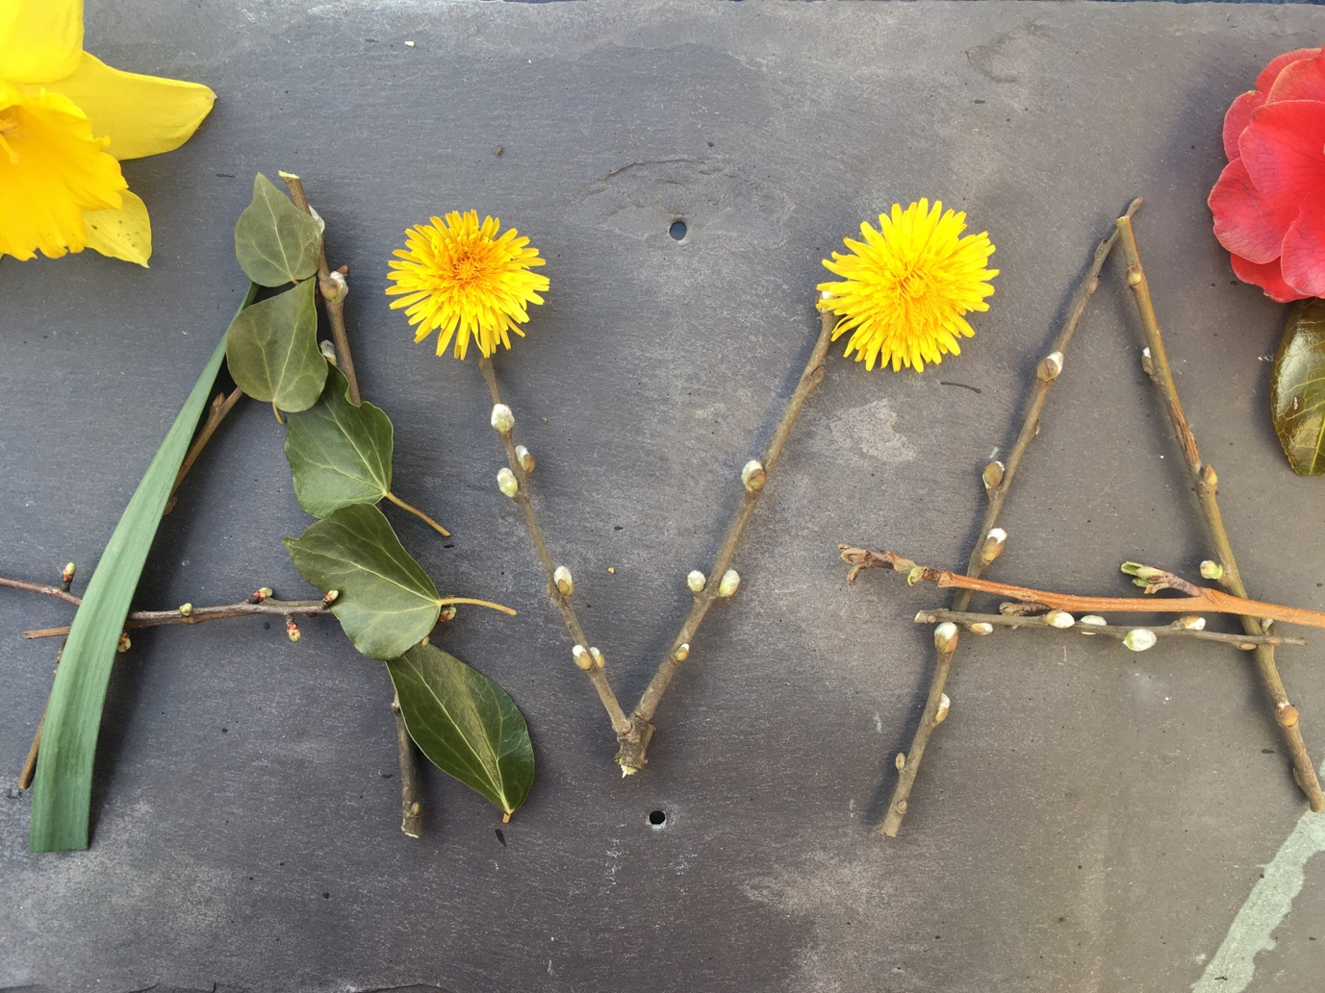

Arrange the twigs and leaves to form your name, see sample…try it out with different arrangements. When your happy with your final piece take a photo and send to HomePlace Facebook page. We would love to see your creations!

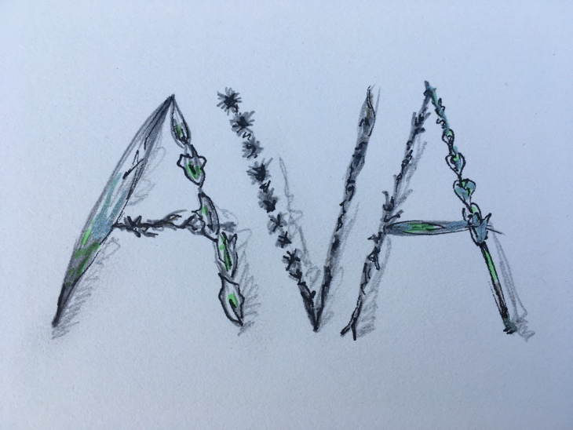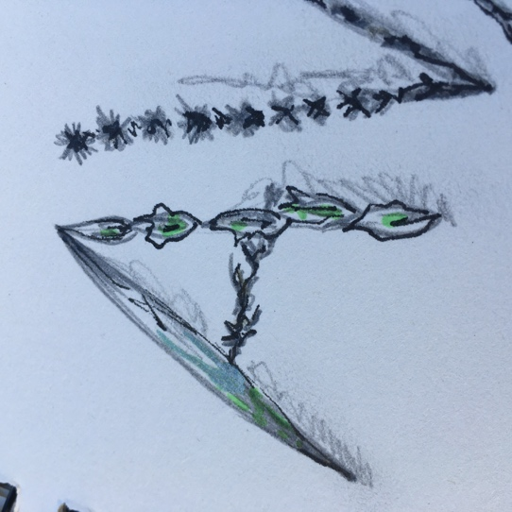

For those of you who don’t have access to the outdoors you could use internet sourced images of leaves, twigs and flowers etc. You could draw or paint from these to create letters to form your name. See sample.

